Oracle Performance Tuning Concept

# Introduction

## Performace Tuning Concept:

* Monitoring and Diagnostics
  + Monitoring using available tools
  + Identifying the problem
  + Using AWR-based tools
* SQL Tuning
  + Identifying and tuning SQL statements by influencing the optimizer
  + Managing change
    - SQL Performance Management
    - Real Application Testing
* Instance Tuning
  + Tuning memory components
  + Tuning space usage and I/O
* Tuning Backup performance
* Tuning for Oracle Data Guard
* Tuning for Oracle Real Application Clusters.

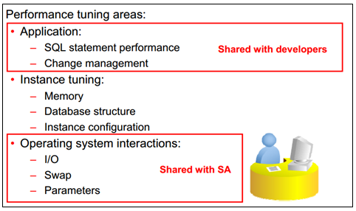

## Tuning Methodology

Tuning steps:

* Identify the scope of the problem (OS, database, and so on).
* Tune the following from the top down:
  + The design before tuning the application code
  + The code before tuning the instance
* Tune the area with the greatest potential benefit:
  + Identify the performance problem (AWR, Statspack).
  + Analyze the problem, looking for skewed and tunable components.
  + Use appropriate tools to tune the components implicated.
* Stop tuning when the goal is met.

## General Tuning Session

Tuning sessions have the same procedure:

* (1) Define the problem and state the goal.
* (2) Collect current performance statistics.
* (3) Consider some common performance errors.
* (4) Build a trial solution.
* (5) Implement and measure the change.
* (6) Decide: “Did the solution meet the goal?”
  + No? Then go to step (3) and repeat.
  + Yes? Then create a new baseline.

## Effective tuning goals are:

• Specific

• Measurable

• Achievable

• Cost effective

## Important

Top 10 Foreground Events by Total Wait Time

Time Model: Example

# SQL Tuning

The Oracle query optimizer determines the most efficient  
execution plan and is the most important step in the  
processing of any SQL statement.  
The optimizer:  
– Evaluates expressions and conditions  
– Uses object and system statistics  
– Decides how to access the data  
– Decides how to join tables  
– Decides which access path is most efficient

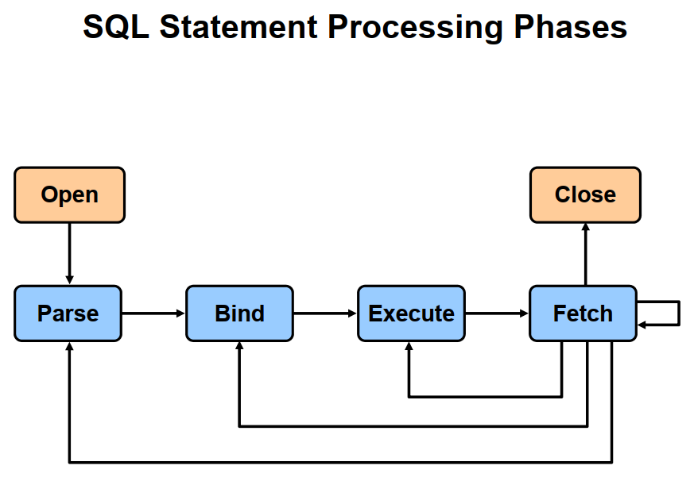

• Parse phase checks:  
– Syntax  
– Semantics and privileges  
• Types of parses:  
– Soft parse:  
— Searches for the statement in the shared pool  
– Hard parse:  
— Merges view definitions and subqueries  
— Determines execution plan

• Bind phase:  
– Checks the statement for bind variables  
– Assigns or reassigns a value to the bind variable  
• Bind variables impact performance when:  
– Parsing is reduced by using a shared cursor  
– A different execution plan might benefit performance with  
different bind values

Execute phase:  
– Executes the SQL statement  
– Performs necessary I/O and sorts for data manipulation  
lang g ( ) uage (DML) statements

Fetch phase:  
– Retrieves rows for a query  
– Sorts for queries when needed  
– Uses an array fetch mechanism

# Instance Tuning

# Tuning Backup performance

# Tuning for Oracle Data Guard

# Tuning for Oracle Real Application Clusters.